1. Shut down the Raspberry Pi

2. Take the MicroSD card out of the pi, insert it into a microSD card reader, and put it into a Windows computer.

3. You should get the following message. DO NOT CLICK FORMAT. Click cancel

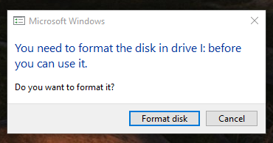

4. Launch Win32 Disk Imager

5. Once Win32 Disk Imager launches, you should see this screen:

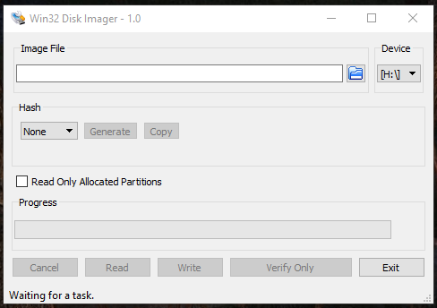

6. Open my computer. You should see only one volume labelled “Boot” or similar. In this case, it is my H:\ drive:
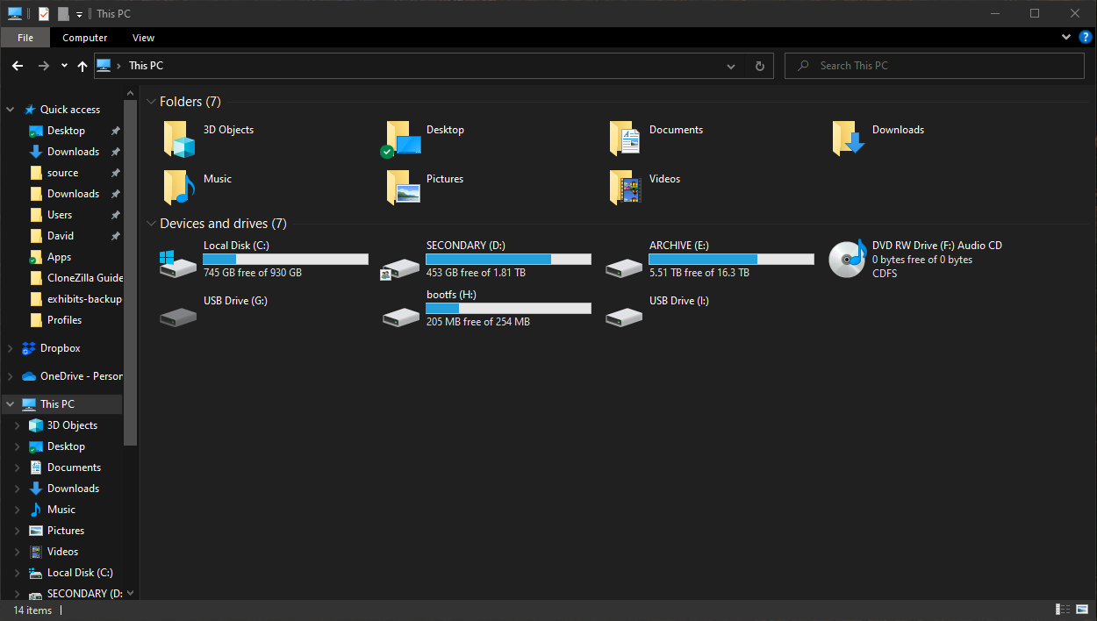
7. Go back to Win32 Disk Imager and select that drive under “Device”

8. Make sure “Read only allocated partitions” is UNCHECKED

9. Click the blue folder icon and browse to where you would like the image saved (This should be the Exhibits – Exhibits Backups - Portable HDD.

10. At this point, Win32 Disk Imager should look like this:
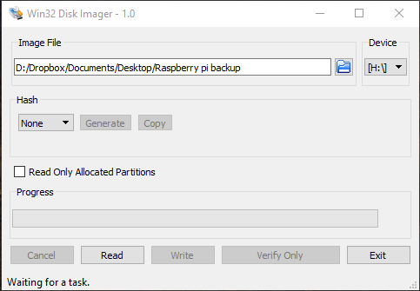

11. Obviously you should name yours something more descriptive. The date of the backup and the name of the exhibit would be a good place to start for what to put in the name. Make sure the filename ends with “.img”

12. Click the read button. At this point, imaging of the MicroSD card should now begin. You will see a time remaining estimate in the bottom right corner.

14. When finished, you should see:

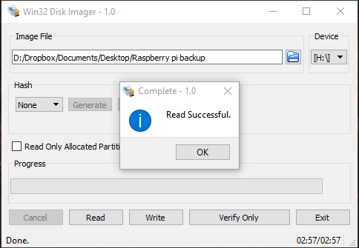

15. Since I forgot to put .img on the end of my filename, I’ll just add it to the resulting file.

16. You are now finished. Put the backup (.img) file somewhere safe and place the MicroSD card back in the Pi. Turn the Pi back on, if needed.

